11 DAY NAMIBIA HIGHLIGHTS MOTORCYCLE TOUR
ITINERARY:
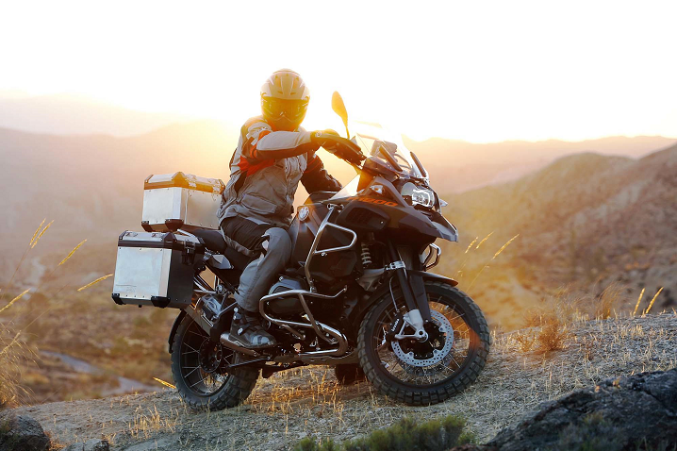
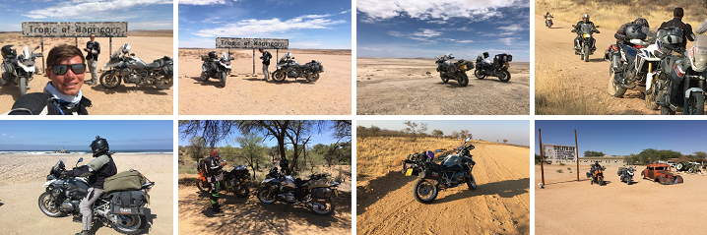
(This itinerary is for agents, and prices only include the rental of bikes, guides, backup vehicles, activities and equipment as stipulated at the end of this itinerary)
Agent to book Accommodation and Meals.

Day 1:
Arrival at Hosea Kutako (Windhoek International) Airport, where you are met by your guide, Wiets. Subsequent transfer to the capital of Namibia for check-in at our self-catering apartment in the city. We sort out the motorcycles and your luggage for the tour.
Dinner and a tour briefing at the famous Joe's Beerhouse (food & drinks for your own costs)

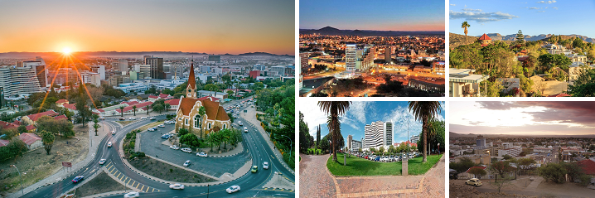

Day 2:
We travel to Sesriem where we will sleep 2 nights.

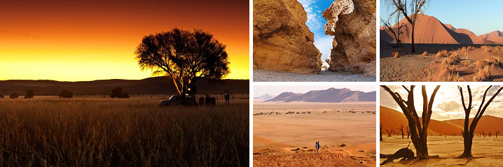

Day 3:
We head out early in the morning (05:00) to visit Sossusvlei, a clay pan surrounded by some of the highest sand dunes in the world, which is filled only with water in years when exceptionally good rainfall is received and also Deadvlei where you can climb the famous Big Daddy dune.
We enjoy a late breakfast at a picnic spot at the dunes, where after we visit the Sesriem Canyon.
We enjoy a sundowner drink at Elim dune.

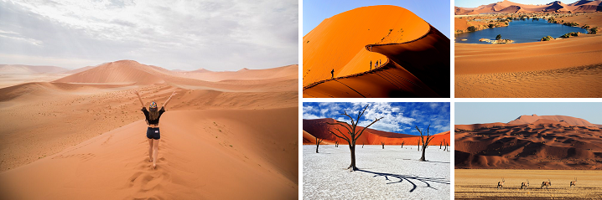

Day 4:
We drive to Swakopmund. It is a quaint desert town with its old-world charm and relaxed atmosphere hedged by desert and sea, is enhanced by lush green lawns and palm trees. The route takes you through the scenic low plains of the Namib Desert via the fascinating geological rock formations of the Kuiseb Canyon

Day 5:
In the morning we visit the Moon Valley landscape in Swakopmund before we travel to Walvis bay to go on an afternoon excursion to Sandwich harbour. To be booked by Matiti
Sandwich Harbour - part of the Namib Naukluft Park - is a place many have heard of but very few have ever visited. Giant sand dunes run straight into the ocean, creating breath-taking sceneries and unique landscapes, just waiting to be discovered! You cannot do a self-drive to this area as only concession holders can take you there on day trips.
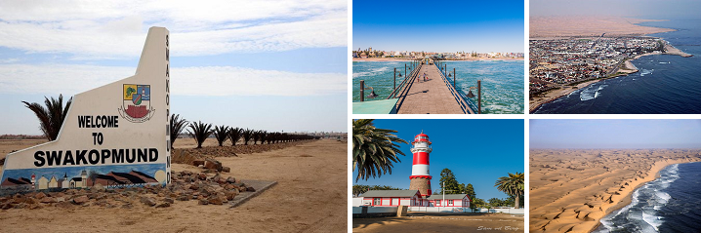

Day 6:
We travel north along the skeleton coast to Cape Cross.
The best-known breeding colony of Cape fur seals along the Namib coast is at this reserve, where the population has grown large and fat by taking advantage of the rich concentrations of fish in the cold Benguela Current. The sight of more than 100,000 seals basking on the beach and frolicking in the surf is impressive to behold, though you’re going to have to contend with the overwhelming odoriferousness of piles and piles of stinky seal poo. From Cape Cross we travel via Uis where we will have lunch to our lodge at the world heritage site at Twyfelfontein.
PLEASE REMOVE CAPE CROSS FROM THE TOUR AND DRIVE STRAIGHT FROM SWAKOPMUND TO TWYFELFONTEIN

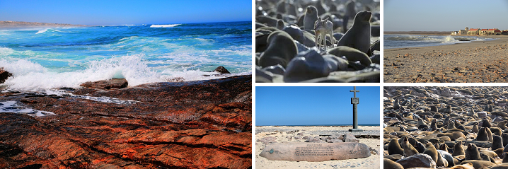

We are Half Way (See MAP):
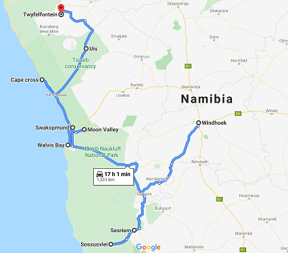

Day 7:
We visit the world heritage site that host more than 1500 bushman Rock art dating back 6000 years. We also explore the Burnt mountain and rock formations called the Organ pipes.
CAN WE STAY AT UGAB TERRACE LODGE OR VINGERKLIP LODGE THIS NIGHT?

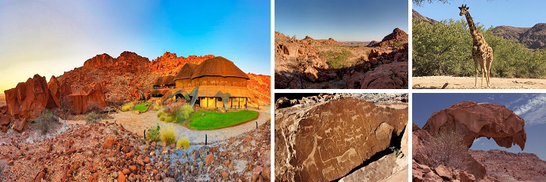

Day 8:
Depart early to a lodge close to the Anderson gate in southern Etosha. On our way we stop at the petrified forest.
Arrive early in the afternoon, time at leisure or on option with supplement safari into Etosha.

Day 9:
We do a full day game drive in Etosha national park with our back up vehicle. At the heart of this National Park is the Etosha Pan, a vast dry shallow depression. Perennial springs feed the waterholes along the southern verge, which attract a myriad of animal species.

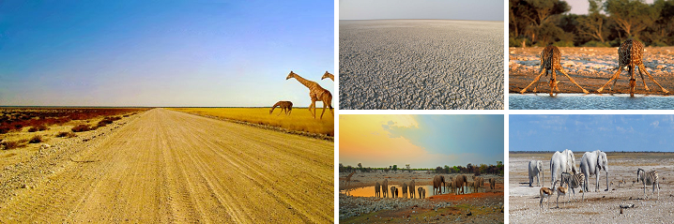

Day 10:
We head south to the Cheetah Ecolodge close to Otjiwarongo. After lunch you can take a rest or spend time at the pool and we do a late afternoon excursion to be booked by Matiti.

CAN WE REPLACE CHEETAH VIEW LODGE BY OTJIWA OR WATERBERG WILDERNESS LODGE?

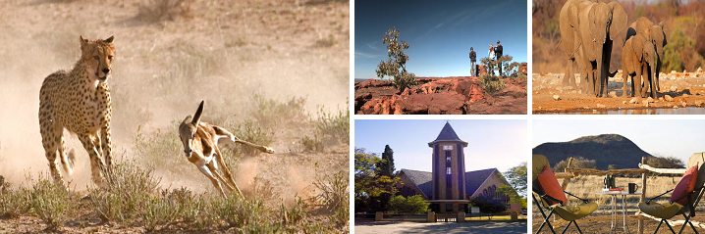

Day 11:
We travel back to Windhoek.
On our way we stop at a craft market where you can buy some traditional craft.
PLEASE END THE TOUR ON ARRIVAL IN WINDHOEK IN THE AFTERNOON

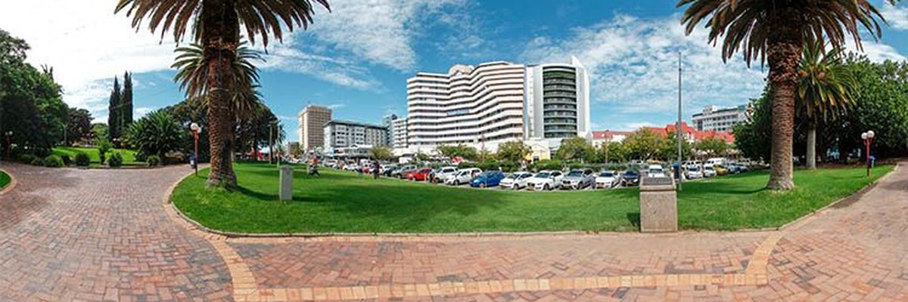

You’ve made IT!
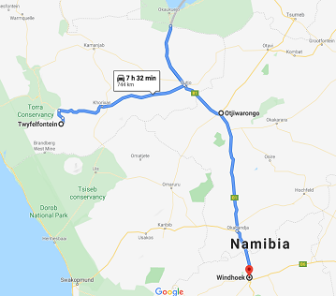

Rates:
13-Day Motorcycle Tour In Namibia:
Group Of: | Engine Size: |  | Price Per Person: |  | Price Per Day Per Person:
4 - 6 Riders | Total GS 1250 |  | NAD 70,400.00 |  | NAD 5,415.38
4 - 6 Riders | Total GS 850 |  | NAD 62,605.00 |  | NAD 4,815.77
4 - 6 Riders | Total GS 750 |  | NAD 61,305.00 |  | NAD 4,715.77
6 - 8 Riders | Total GS 1250 |  | NAD 66,770.00 |  | NAD 5,136.15
6 - 8 Riders | Total GS 850 |  | NAD 58,850.00 |  | NAD 4,526.92
6 - 8 Riders | Total GS 750 |  | NAD 57,550.00 |  | NAD 4,426.92
8 - 10 Riders | Total GS 1250 |  | NAD 64,891.00 |  | NAD 4,991.62
8 - 10 Riders | Total GS 850 |  | NAD 56,970.00 |  | NAD 4,382.31
8 - 10 Riders | Total GS 750 |  | NAD 55,660.00 |  | NAD 4,281.54
Extras: Pillion NAD 20000

Booking Information:
Bookings will only be confirmed when a 50% Deposit is in our bank account. Full payment is required 30 days before start of tour date.
Prices Include:
Motor Cycle Rental
Protection Gear if Needed
Guide – must we cater for the guide accommodation and meals?
National Park Entry Fees – CAN THIS PLEASE BE TAKEN OUT AND CLIENTS PAY ALL ENTRANCE FEES THEMSELVES?
Backup Vehicle
All Activities as per Itinerary
Prices Excludes:
Accommodation
Fuel (Each rider fills up on his own cost)
Holiday, medical or personal insurance.
Personal needs or items such as laundry and phone calls
Flights to and from Namibia
Visa
Alcoholic beverages or any drinks in restaurants/hotels/lodges.
Breakfast, Lunch & Dinner
Optional Activities
Additional Information:
Please note that the road conditions in Namibia change due to rain and other influences such as traffic during high tourist season etc.
The pace of the riding will be determined by the guide and the riding skills level of the riders on tour. Your safety is our highest priority.
You will have the opportunity to stop for photos at any point during the tour.
The guide is an experienced rider / instructor that will give you riding tips and assistance during the tour as terrain changes are frequent on all gravel roads.
No riding will be done after sun set or before sun rise (unless a special request is made during the tour to do a short night ride) that will be decided by the guide depending on your riding skills level.
The guide will have a satellite emergency device on hand that is linked to various emergency centres in Namibia.
The backup vehicle will have a fridge with water for stops during the ride.
Your luggage will be transported in the back up vehicle.
Each rider will receive an emergency panic button.
As for any other general knowledge just keep the following in mind when communicating with your clients:
Insurance Excess & Credit card authorizations: Please refer to the rate sheet below to ascertain the amount we will authorize on a customer’s credit card for each bike.
Although our bikes are fully covered for insurance purposes, the rider still remains responsible for the excess amount before the insurance will pay out for any claim.
Authorizations are done on the rider’s credit card on the day of collection. The hold on the rider’s credit card is only released 7 days after the end of the rental period.
In case of any accidents or traffic fines the operator and client will be informed via email of the relevant charges and billed to the rider’s credit card.
Refundable Excess Per Bike: |  | Total GS 1250 |  | NAD 30,000.00
 |  | Total GS 850 |  | NAD 25,000.00
 |  | Total GS 750 |  | NAD 25,000.00
Cancellation Fee:
Booking Deposit: 50% of rental amount to confirm booking Cancellation 30 Days or more before booking : 50% of rental amount retained

PS. We can amend Itinerary as per your clients’ needs.
Let’s ride Namibia!

